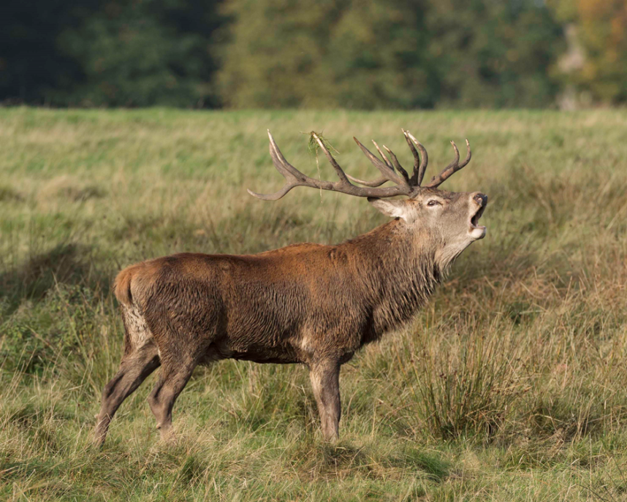
Autumn is the season of the deer rut and Tatton is a fantastic place to come and witness it first hand. The antlers are now cleaned up and the velvet has been frayed off. The deer are now known to be in ‘hard horn’. The shortening daylight hours trigger the start of the rut. The males split away from each other and will begin to thrash their antlers on the ground sometimes adorning them with long grass. They make muddy hollows with their hooves and antlers, urinate in them, and then wallow in them! This visual display and pungent smell warn other males away and attract females. The Red Deer have a loud, far carrying bellow whereas the Fallow give a snorting, rasping call. The Red Deer herd a group of hinds together known as a harem which they protect against rival males. The strongest males have the bigger groups therefore spreading the strongest genes among the herd. When the top stags are ‘spent’ or ‘run’ younger males may have chance to mate. The Fallow Deer employ a different tactic where they attract does to their territory known as a ‘stand’. If two suitors are evenly matched then actual fighting may take place although this is a last resort. Antlers lock together in what is basically a pushing match and a test of strength, the strongest seeing off its rival and often giving a victory call when doing so. Females are only in season for a short time and it is important that they are mated early, if they are not during their first cycle, this will result in late calves next year which never do as well. The males have little time to feed during the rut but a good acorn crop helps them to replenish their fat reserves before winter. Over the summer months the drought conditions have had some effect on the deer. They have been grazing in woodland areas more where the ground has not been scorched. Deer numbers are purposefully kept at the correct stocking level to maintain the grass sward and provide ample grazing. The ranger team will be running special deer walks during the rut so why not come along and learn more about this fascinating time of year in the deer calendar? Pre-booking is essential by calling 01625 374428 or book online via the events tab on Tatton’s website. The cost includes park entry.
Autumn is also the best time to look at the many and varied species of fungi that can be found in the park. Tatton is a great place for them as we have a policy of leaving dead wood in-situ and standing dead wood where we can. Some fungi use this dead or dying wood as a host species meaning certain fungi can be found only with specific trees. Some, such as Waxcaps, thrive in the park’s grassland habitat. They are a beautiful species to look for as they come in a variety of stunning colours. Parasol mushrooms are also common in the park and are impressive for their sheer size alone. There are also types of bracket fungi to look for, Beefsteak fungi and Giant Polypore being particularly impressive. It is against National Trust by-laws to take any fungi from the park and we actively discourage foraging of any kind, it is far better to leave them for other visitors to enjoy. There is a fantastic opportunity to look at our fungi species on Sunday 21st October when fungi expert Fungal Punk Dave and a park ranger will be leading a guided walk. As stated above species are not collected for culinary use but it is a chance to find some magnificent specimens and learn some amazing facts! Pre-booking is essential by calling 01625 374428 or book online via the events tab on Tatton’s website. The cost includes park entry.
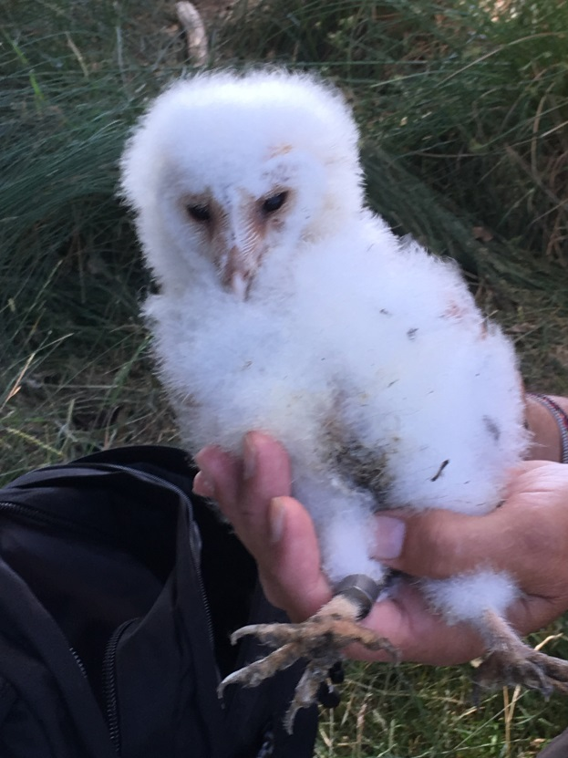
The ranger team monitor a variety of nest boxes in the parkland which target certain species. One of which is the Barn Owl and we have several boxes around to tempt them to take up residence. One of our rangers holds a special schedule 1 licence which allows him to legally check the Barn Owl boxes annually. The boxes were not used this year but he did find a nest near to one of the boxes in a hole in a tree. A couple of weeks later we had the owlets ringed. This is a process where a metal ring is attached to the bird’s leg with contact details for the British Trust for Ornithology. If the bird is found, valuable data can be discovered such as how long it has lived and how far it has travelled. One of the owlets is pictured on the left showing the ring.
A family party of Ravens were seen in July and it is thought three pairs nest here each year. A Green Sandpiper was also present by a pond in the Deer Enclosure, a sure sign that return migration is underway. Our Green Woodpeckers have also fared well too and Tatton is a great place to see them. Their presence is usually given away by their loud ‘laughing’ call and unlike other woodpecker species can be seen on the ground where they search for ants, their favoured food. Autumn is a great time to look for unusual birds as this is the peak migration time. Winter visitors will be arriving and the last summer birds will be heading south. Wheatears are now passing through and warbler species are on the move also. September is the best time to look for Hobbies; this small falcon is a summer visitor to Britain and will make the most of an easy insect meal over Tatton Mere before departing to Africa.
During the autumn, trees and shrubs will be adorned with nuts and berries and these are important to the survival of many birds and mammals. Birds love to feed on Elderberry and Rowan and Hawthorn is a favourite too. Whether it is departing birds building up strength before migrating or a new arrival refuelling, they provide a valuable resource. The Sweet Chestnuts and acorns certainly give the deer a much needed boost after rutting before winter.
The South Lancashire Bat Group has resumed trapping after taking a break during the maternity season. The first night yielded an interesting capture, a ringed male Nathusius’s Pipistrelle previously caught in 2016. He was heavier than two years ago and was in good breeding condition. These are a scarce migratory species, but research is currently trying to establish whether we have breeding populations in this country.
Compiled by Tatton’s Ranger Team

